Project

**Record Payment Scheduler : BAPI**

# Business Scenario

This API will record all missing transactions in payment DB.

# API Landscape

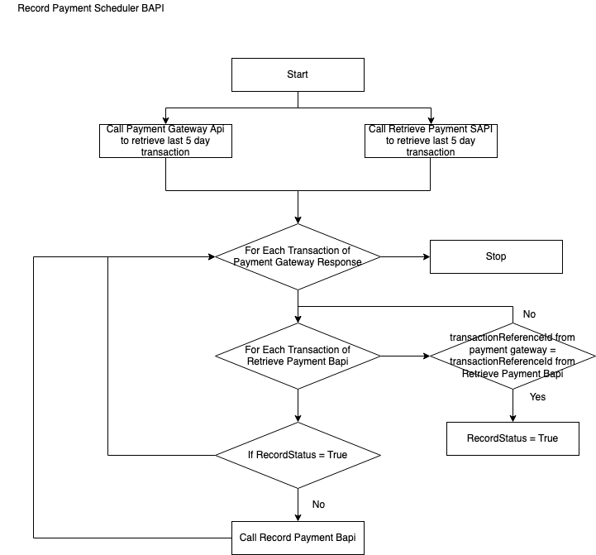

Sequence Diagram Web Application

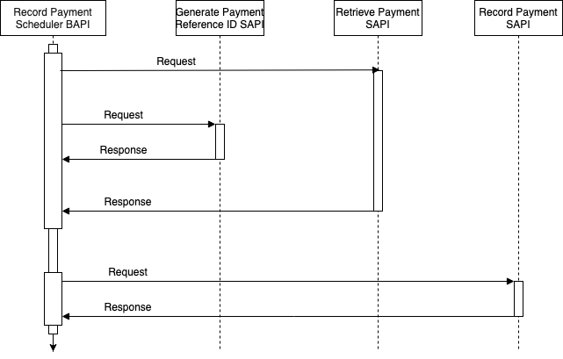

API Details:

|  |  |
| --- | --- |
| **Version** | 1.0.0 |
| **Resource** | gatewayPayments |
| **Method** | Scheduler Based API :Run every 30 min |
| **Objective** | This API will record all missing transactions in payment DB. |